**Creating a Class Library**

1. Create a new Project and select "Class Library (.NET Framework)"

It MUST be the one with **.dll** in the description. The highlighted one below:

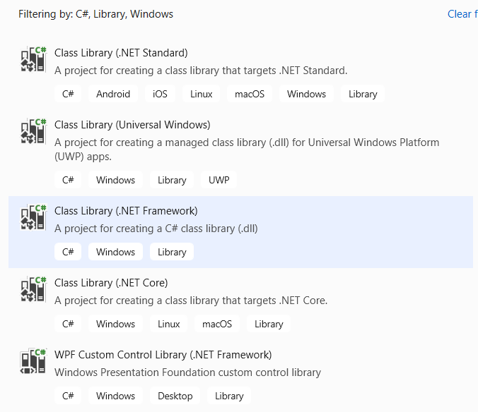

1. Use the same sensible namespace throughout (usually the name of the project - eg. CafeLib).
2. Put each class in its own source (.cs) file
3. There will be no Main() entry point function in the class library to test with. You need to have a separate application to test your classes.
4. Build the solution. Ensure the .dll file is in the bin\debug subfolder of your project.

**Adding the DLL Reference to an Application**

1. Create a Console App or a Windows Forms App (the name **must** say ".NET Framework")

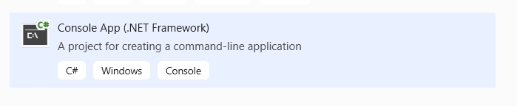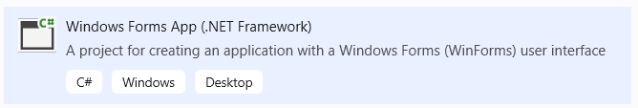

1. In the Solution Explorer, right-click References and select "Add Reference…"

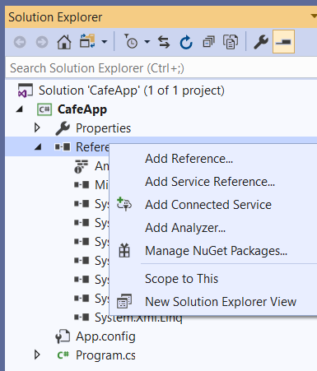

1. Click "Browse" on the toolbar on the left, and click the "Browse…" button at the bottom. Locate your .dll file in the bin\debug folder and click "Add". Then click "Ok".

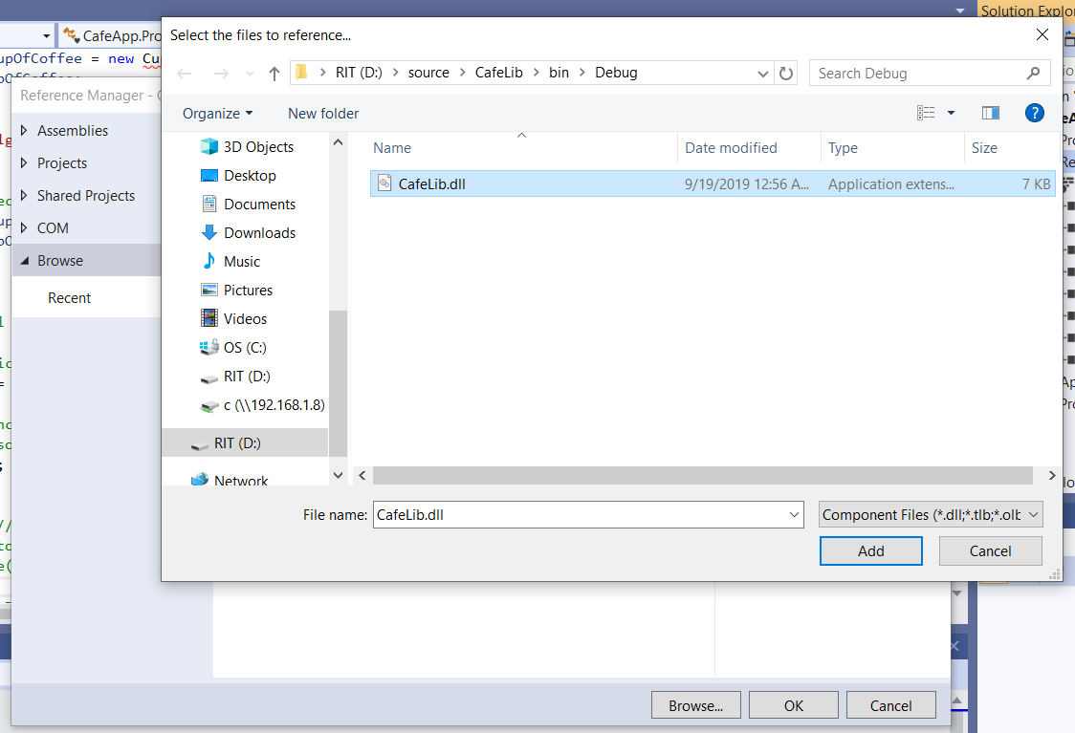

1. You can now reference your Class Library in your application.

